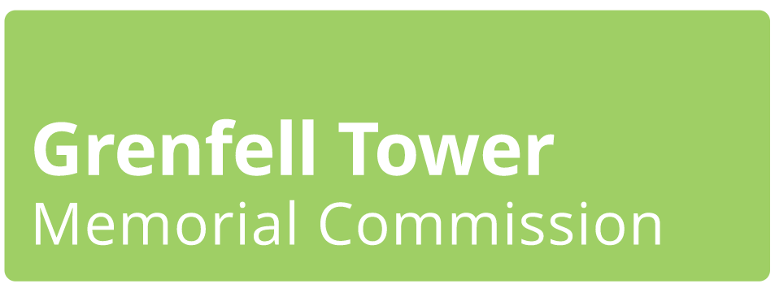

The February events:
The independent Grenfell Tower Memorial Commission is holding several drop-in events in February. The events are an opportunity to find out about the Memorial Commission, the work to finalise its membership, and its plans for the future. Visitors can meet the commission’s community representatives, ask questions and learn more about how to be involved in what happens next.
What is the Memorial Commission?
The Grenfell Tower Memorial Commission is made up of bereaved family members, survivors and Lancaster West residents. It will work with the community to decide on the most fitting way to remember those who lost their lives in the Grenfell tragedy, and on how the memorial site will be owned and sustainably managed in the future.
The government has taken ownership of the site and is committed to keeping it safe and making it ready for the future memorial. The site will then be transferred to an appropriate body chosen by the Commission and community.
It is made up of:
• Ten community representatives, to represent the bereaved families, survivors and North Kensington residents.
• Two independent co-chairs selected by the community representatives to structure the plan for how we get to memorial design. The co-chairs will be the public face of the Commission.
• The Commission will be supported by a small number of public authorities and several experts. Administrative support will be provided by the Ministry of Housing, Communities and Local Government.

The co-chairs are:
• Thelma Stober: Head of Legal at the Local Government Association and a member of the government’s Victim’s Panel. She is a survivor of the 7/7 London bombings and has worked on previous memorials.
• Michael Lockwood: Director General of the Independent Office of Police Complaints and formerly the chief executive of Harrow Council, Michael was brought in to manage the Grenfell site team and lead on recovery and engagement with the bereaved and survivors until January 2018.
The Memorial Commission’s work is anticipated to include:
Getting out and about in the community and listening to what people think and would like to see in the future memorial.
Hosting community events and other activities to identify the main ideas and themes that are coming up; then sharing that information with the bereaved, survivors and community.

Working with experts, including architects and designers, to develop design criteria for the memorial. Also considering options for the memorial site’s future ownership.

Consulting the community on the most popular ideas to find out the preferred option for the memorial design and future ownership.

Throughout its work, the Commission will:
• Actively seek views from bereaved families, survivors and the community and reflect them in all discussions about the future memorial.
• Work with you openly, making sure there are opportunities for everyone to get involved and have your ideas heard. Important discussions will not take place behind closed doors.
• Work with you to develop ideas for an appropriate memorial.
• Keep you updated on the events, workshops and other opportunities so that you can stay involved.
The Commission will produce a community-led proposal that sets out:
• What it has heard.
• The community’s view on a fitting and lasting memorial to remember those who lost their lives.
• The community’s view on the design considerations and criteria.
• How the memorial should be owned and sustainably managed for the long term.
The Memorial Commission’s work is expected to take place during 2020 and 2021.
What has happened so far, and what can you expect
• March 2018: The government publishes a set of principles, signed by the council, committing ‘to put the community at the heart of deciding the long-term future of the site, assumed to be a memorial.’ (available at www.grenfelltowermemorial.co.uk).
• August 2018: The government announces it will take responsibility for the Grenfell Tower site until the land is made ready for future use, for a memorial decided by the community.
• September 2018: The intention to establish an independent Grenfell Tower Memorial Commission is announced.
• November: The government announces it will take freehold ownership of the Grenfell Tower site and commits to meet the ongoing costs of keeping it safe and secure until it is ‘prepared and made ready for future use’, assumed to be a memorial.
• July 2019: The government completes the transfer of ownership of the site. It reaffirms its commitment that the community would determine a fitting and lasting memorial, and puts a legal covenant in place to protect the site. For example, from redevelopment. The ten Memorial Commission community representatives are voted in. Discussions begin to agree the Commission’s ways of working and to finalise the rest of the Commission’s membership including chair(s).
• February 2010: Grenfell Tower Memorial Commission introductory events with the bereaved, survivors and local community.
• Spring 2020: Grenfell Tower Memorial Commission will be out meeting and hearing from the community, and raising awareness of its work.
• Summer 2020: Ideas will be gathered from the community via a range of open, face-to-face and online discussions and consultations. These will be promoted and you can also keep yourself informed by joining our mailing list at: www.grenfelltowermemorial.co.uk/contact

FAQs
Q: The times and/or locations of these events were not possible or convenient for me. How else can I get involved?
A: If the times, locations and/or format of these events do not work for you, or if you would like to suggest alternative ways of the Commission holding future events, please email us at: GTMCSecretariat@communities.gov.uk
Q: How can I find out more about what the Commission is doing?
A: Please visit the Commission’s website and sign up to our mailing list at: https://www.grenfelltowermemorial.co.uk/contact
Q: Who manages the Grenfell Tower site at the moment?
A: The government has taken ownership of the site and is committed to keeping it safe and making it ready for the future memorial. The site will then be transferred to an appropriate body chosen by the Commission and community. For more information on this, come to the Wednesday drop-in session at the Curve Community Centre (10 Bard Road, W10 6TP). No appointment needed.
You can also visit the gov.uk website and search for a page called Grenfell Community Updates. This contains regular updates about the day-to-day management of the Grenfell Tower site.
Useful contacts
Grenfell Tower Memorial Commission: GTMCSecretariat@communities.gov.uk / Telephone: 0303 444 4831
Grenfell Tower site management: GrenfellTowerSite@communities.gov.uk /
Telephone: 0303 444 0011

